Chevrolet : Other pickups
1955 First Edition 5 Window 3600 Pick-up
Miles: | 76726 | Doors: | 2 doors
Transmission: | Manual | Interior: | Green
Engine: | 8 - Cyl. | Year: | 1955
Warranty: | No | VIN Number: | J551005486
Title: | Clear | Exterior: | Gray

Vehicle Description
1955 First Edition 3600, 5 Window Pick-up. Originally sold in the desert of Las Vegas and has been in the dry climate it's entire life. This truck has no rust! Cab corners, normally the trouble spots, are rock solid. Truck is almost ready for paint. Bedliner planks could use some work. This truck has a 1969 Camaro 327 engine that runs very well. Granny gear 4 speed transmission adds a touch of nostalgia to the rush of driving a really strong truck! I bought this truck to finish it off and have had no time to do it. This truck deserves to be finished up and I just can't get to it.
Vehicle Condition
This truck is not perfect but not to far from it. A couple small dings on right front fender. Pictures for this vehicle will follow shortly. Two extra doors (one for each side) and new headlight doors and trim. New Battery, great wheels and tires.

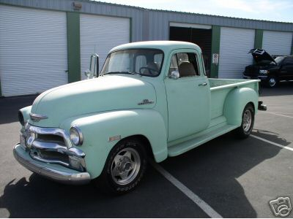 |  | Click on a picture to enlarge
 |  | 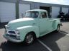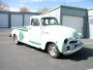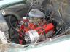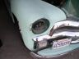 | 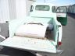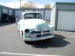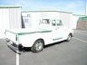 | 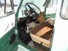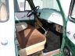
Bottom of Form

